Job Title | Impact and Insights Officer
Department | Central Services
Location | Home-based with regular travel to sites across Herts, Beds & Bucks
Reporting to | Impact and Insight Manager
Grade | G5
Vetting | Standard DBS
Travel | Access to a vehicle for travel in the course of your work, along with suitable business insurance to cover work-related travel

Main Purpose of Role
The YMCA provides a range of social housing, sports, health and wellbeing, children’s services, youth and community activities for the benefit of local people and communities across Hertfordshire, Buckinghamshire, Bedfordshire and beyond. YMCA is committed to making a difference through the services it delivers and the partner organisations it works with.
As an Impact and Insights Officer within the Impact and Insight team, you will play a key role in helping One YMCA use data to understand and improve its services. Your work will support the organisations mission by turning raw data into clear, useful insights that inform decision-making and help demonstrate the value and impact of our work.
You’ll work closely with colleagues across departments to gather, organise and analyse data – helping service leads measure what matters most. By creating reports and visualisations you’ll show how One YMCA is making a difference for the people and communities we serve. For example, collaborating with the Human Resources team to analyse employee retention data and identify strategies to enhance staff engagement and long-term commitment.
This role is ideal for someone who enjoys working with data and wants to see it used to make real-world improvements. You’ll contribute to building a culture where data is valued and used effectively, and you’ll support the wider teams in developing evidence that can be shared with internal and external stakeholders.
You will be encouraged to suggest improvements to how we collect and use data, and to explore new tools and approaches that make our work more efficient and impactful. Your skills will help One YMCA continue to grow as a learning organisation - one that empowers individuals to belong, contribute and thrive.

Where your role fits in the team

Role-specific responsibilities
- Your contributions will help produce clear, meaningful reports and visualisations that demonstrate progress against strategic priorities, including the Twenty by 30 strategy.
- You will support the central collation and analysis of data to help One YMCA measure and evaluate its impact across services.
- You will work closely with colleagues across service areas to understand their data needs and ensure their impact is captured within central systems.
- You will assist in designing and developing evaluation and reporting tools and support the creation of service-specific measurement frameworks where needed.
- With your knowledge you will prepare materials that can be shared with internal and external stakeholders, including partners, commissioners, and local authorities.
- You will provide timely and relevant data support to inform service development and operational improvements.
- You’ll apply your technical skills in data analysis, survey design, and reporting to support the wider team and help build data capability across the organisation.
- You will also contribute to ensuring consistent data capture and robust evidence of outcomes through effective evaluation processes.
- You will share ideas for improving data systems and structures, helping One YMCA strengthen its business intelligence and align with its strategic goals.

General Responsibilities

As part of your commitment to professional growth, you will actively engage in continuous personal development to ensure your skills and knowledge remain up to date and aligned with best practice. You will be expected to uphold the highest standards of confidentiality and data security, always following One YMCA’S policies and procedures.
You will support and promote sustainable working practices, contributing to effort that reduce the organisation’s environmental impact. A strong alignment with One YMCA’s values is essential, along with a clear commitment to equality, diversity and inclusion in all aspects of your work.
A good understanding of your role and how it fits within the wider organisation will help you contribute to innovation and positive change. You will work collaboratively with others to improve operational efficiency, encouraging the use of streamlined processes and technology to enhance effectiveness and support continuous improvement.

Person specification
Key skills and Attributes
To thrive in this role, you will bring analytical skills and a collaborative mindset, with the ability to work effectively both within a team and independently on assigned tasks. You will be comfortable working in a dynamic and evolving environment, applying creative thinking to overcome challenges and support progress.

You will build effective working relationships across the organisation, demonstrating a solution-focused approach and a willingness to support others. Your ability to challenge processes constructively and sensitively will contribute to continuous improvement and innovation. A proactive attitude and a strong sense of accountability will help you deliver high-quality work while empowering those around you.

Confidence in using Microsoft Office 365 – particularly Excel, Word and Outlook – is essential, and you will use these tools to support your analysis and reporting. Above all you will demonstrate a clear commitment to One YMCA’s purpose and values, including a focus on quality, inclusion and social impact in everything you do.

Knowledge and Experience
You will bring experience and working knowledge of research evaluation methods, with a proven ability to apply these techniques to assess and communicate impact. Your skills in quantitative data analysis will be key to producing clear, evidence-based insights that support both strategic planning and day-to-day decision making.

Experience using CRM systems such as Salesforce and business intelligence tools like Power BI is desirable. These platforms support effective data capture, analysis and visualisation – helping to communicate One YMCA’s impact and identify opportunities for service improvement. However training will be provided for candidates who are keen to develop these skills.

Importantly, you will have some experience using data to influence change – challenge assumptions, informing strategy and supporting innovation through a data-driven approach.

Qualifications or training required (or appropriate demonstrable experience)
You will hold a Level 3 qualification in a data-related field or demonstrate equivalent relevant experience. In addition, you will have completed training in GDPR and Cyber Security, ensuring a strong understanding of data protection and information governance.
Due to the nature of the role, you must have access to a vehicle for work-related travel, along with suitable business insurance. A full Great Britain driving licence is required. If you have more than three points on your licence, we encourage you to contact us before applying to discuss your circumstances.

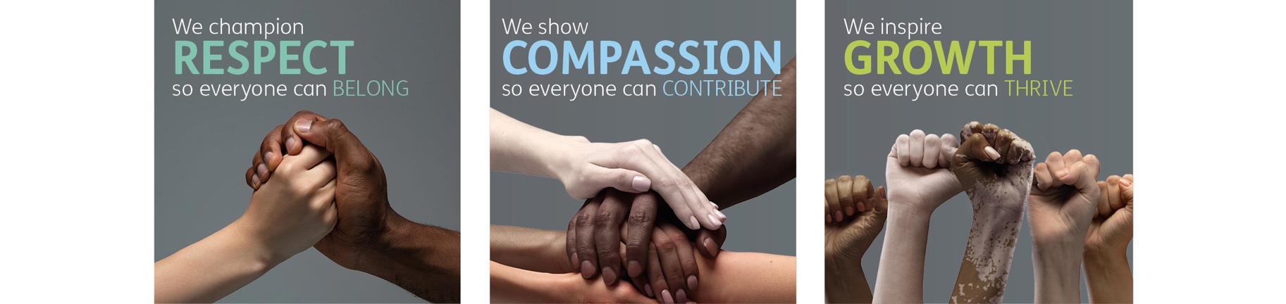
Role competencies, from One YMCA’s Competency Framework
RESPECT
- I treat everybody with dignity and respect
- I follow the principles of EDIB in everything that I do
- I do what is asked of me to the best of my ability
- I work within my professional boundaries
Compassion
- I support the needs of colleagues and service users
- I approach challenging situations with empathy and care
- I act with desire to make people’s lives better through my work
- I know when to escalate difficult issues to my manager
Growth:
- I make sure I understand the purpose of my role
- I look for way to improve my contribution and use my initiative
- I solve problems when they occur or find solutions with my manager
- I take responsibility for my development whilst listening to my manager’s advice
- I keep up to date with new information and processes in my role

Equality, Diversity, Inclusion & Belonging Statement
At One YMCA we are an inclusive organisation and actively promote equality of opportunity for all with the right mix of talent, skills, and potential. We do not discriminate on the basis of Age, Disability, Gender Reassignment, Marriage/Civil Partnership, Pregnancy/Maternity, Race, Religion/Belief, Sex and/or Sexual Orientation. We encourage applications from all backgrounds, communities, and industries, and are committed to having a team that is made up of diverse skills, experiences, and abilities.

